
Jaypee Univeristy of Information Technology, Waknaghat Solan H.P

Solution Sheet
Red Black Tree

Q1)Answer: Red Black Tree Rules:
- Every node is colored either Red or black .
- The root always is black.
- If a node is red then its children must be black. (i.e. no two red nodes must be together a.k.a. the red rule).
- Every path from a node to a null link must contain the same number of black nodes (a.k.a. the path rule).
- All null link nodes are black, empty and store no data.

Q2) Answer: a
Explanation: Though both trees are balanced, when there are more insertions and deletions to make the tree balanced, AVL trees should have more rotations, it would be better to use red-black. but if more search is required AVL trees should be used.

Q3) Answer: a
Explanation: The node pointers can be used to store color with the help of significant bits. the exceptions of this method are in languages like java where pointers are not used, this may not work.
Computers generally align objects in memory. For example, if a node must be aligned to 8 bytes, its address will be a multiple of 8.
Therefore, the last three bits of its address will always be zero. So last bit can represent the node's color if that bit is guaranteed to be unused by the address.
We can use that bit to encode the color:
- 0 = Black
- 1 = Red

Q4)
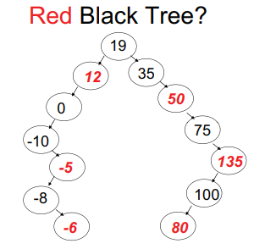
Answer: b
It is a BST as each node follows property of BST.
Consider path, 19 -> 12 -> 0 -> -10 -> NULL : No. of black nodes = 3
Consider path, 19 -> 35 -> 50 -> 75 -> 135-> 100 -> NULL : No. of black nodes = 4
In both paths number of black nodes are different.

Q5) Answer: a ; It follows property of both BST and RBT
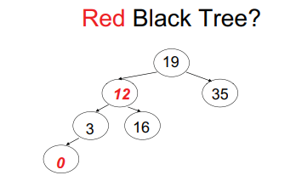

Q6) Solution
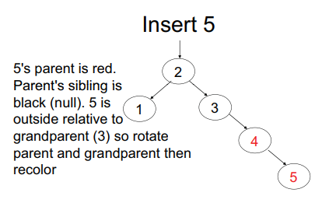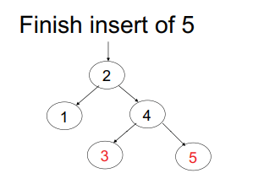
Q7)
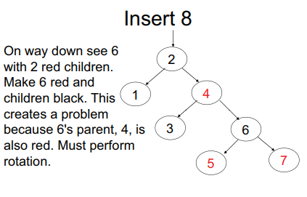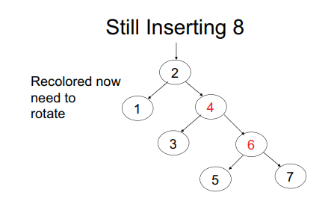
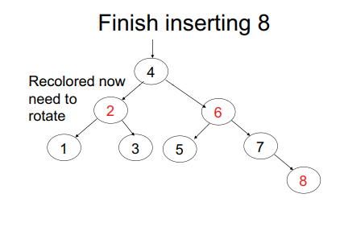
Q8)
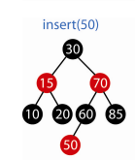

Q9)
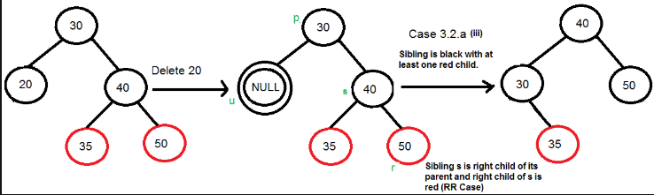

Q10)
